Computer Language Coding Concepts

Command Call in a Diagram
The principle of a command call is explained in the article Command Call. This article demonstrates its expression in a diagram.

A command call is an instatiation of its definition. The instantiation of the definition is executable. A command call has a diamond shape, which stands for execution:



What makes a call a call, is that it redirects its class target to its definition. So an active command symbol with a definition line is a call:

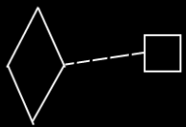

Because the definition is the prototype of the call, and not the same object as the call, a dashed class line needs to be used to point out the definition of a call.

A call does not have to be placed inside another command. It can also be placed inside an object, in case of which somebody has to manually run the executable object.

See also: Command Call, Commands

Author & Copyright: Jan-Joost van Zon Date: May 24, 2008 – August 13, 2008 Location: Oosterhout, The Netherlands Status: Finished

